Annual gender sensitization action plan

Enclosure
(Gender Sensitization Programme – Images)
(June– 2020 to May– 2021)
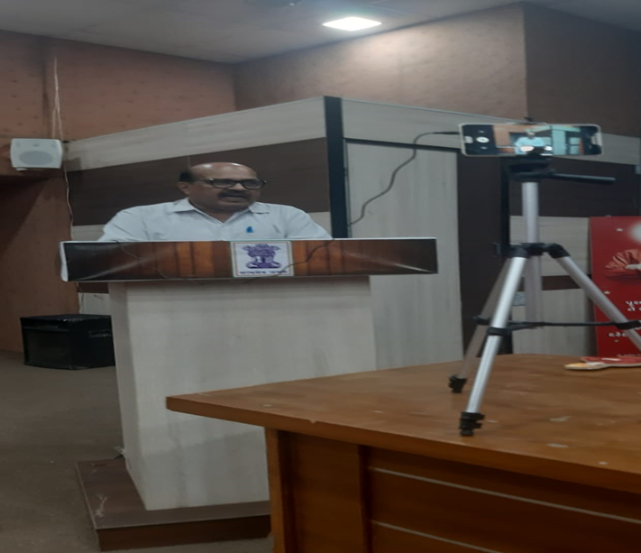
26/11/2020
Bandharan divas -Lecture on Rights and Duty
“Gender Sensitization Training”
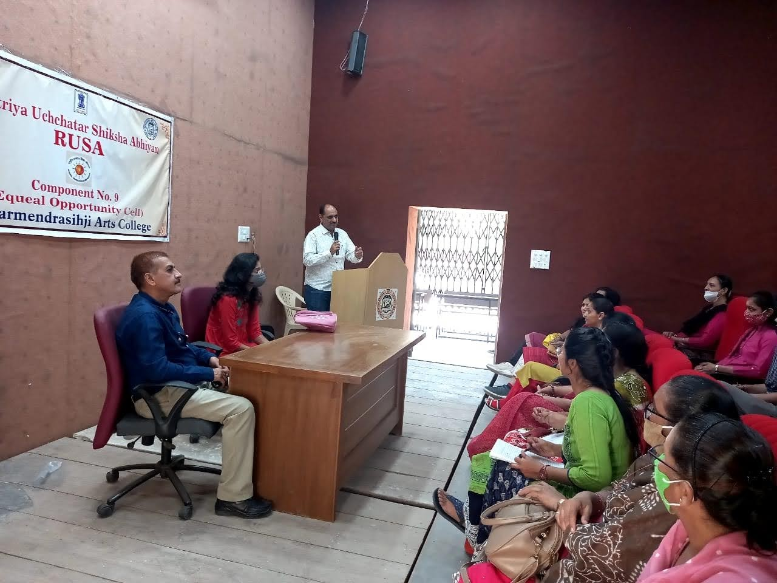

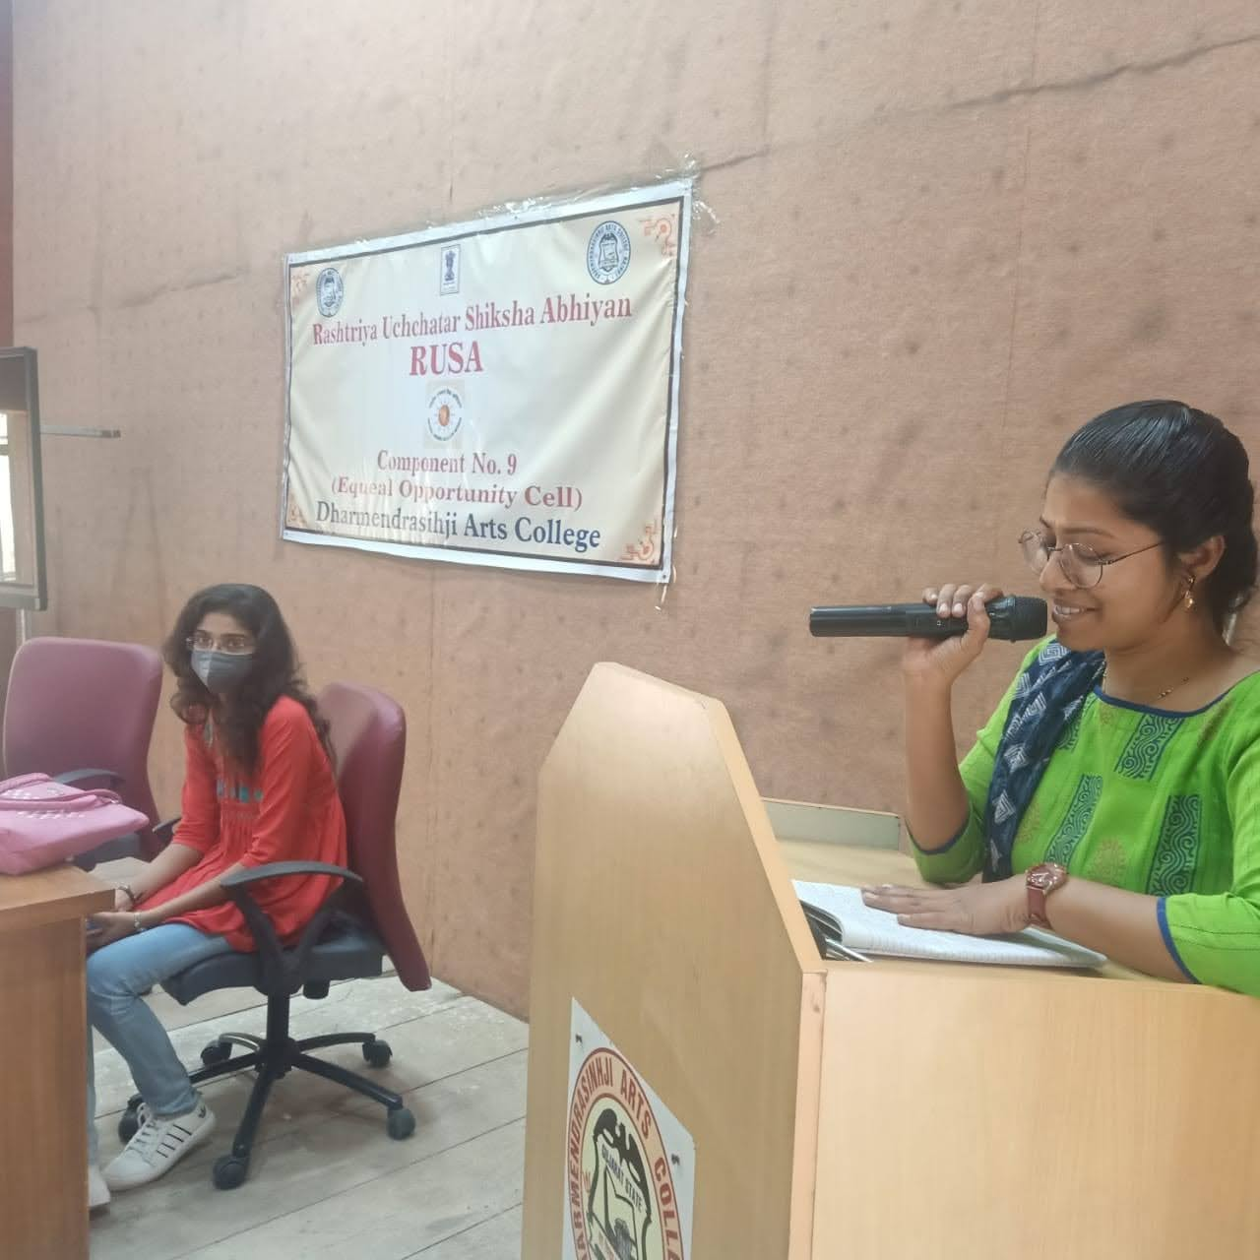
Organised on 19.02.2021, at Dharmendrasinhji Arts College, Rajkot.

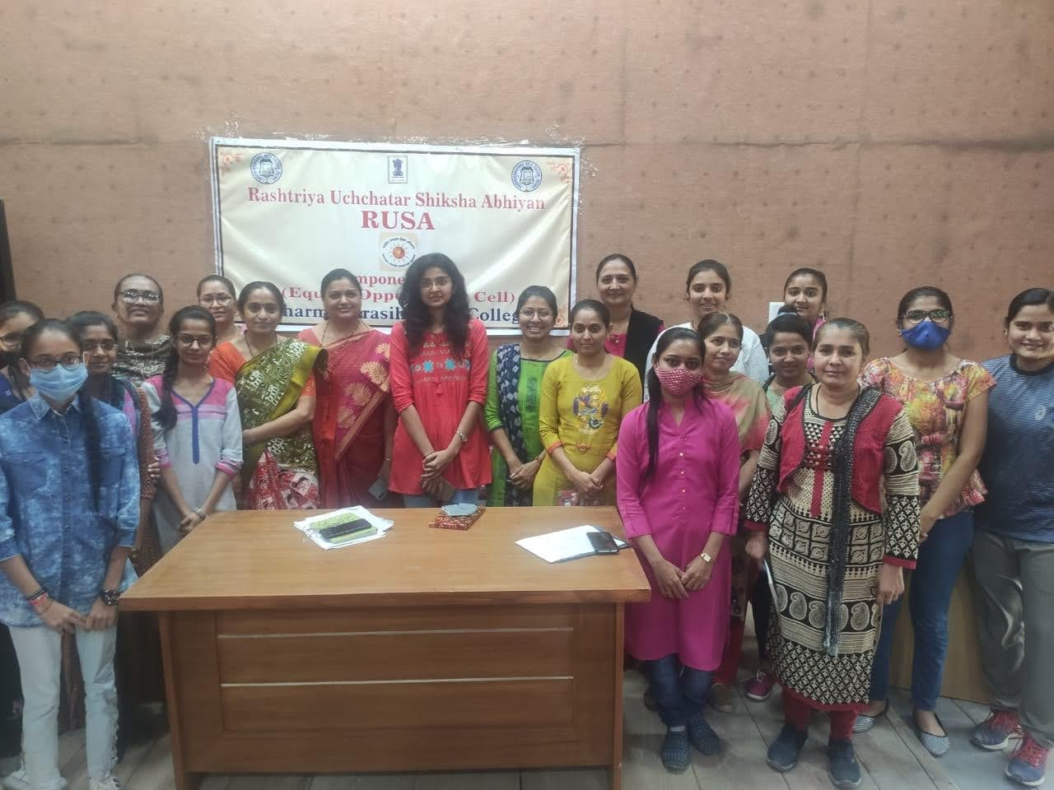

Participants of the Training Programme

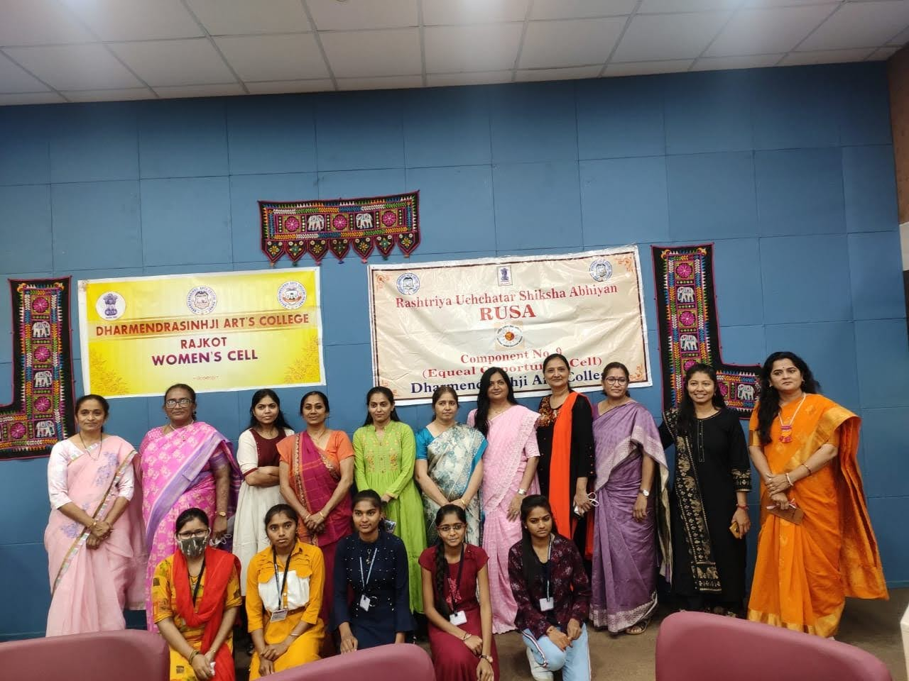
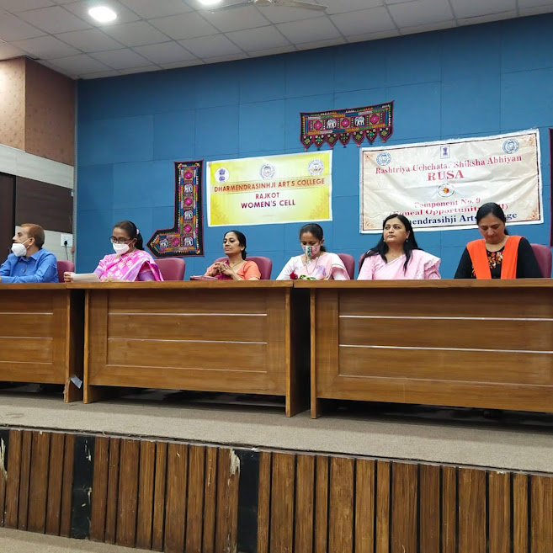

Celebration of Womens Day

Organised on 8/03/2021 at Dharmendrasinhji Arts College, Rajkot.

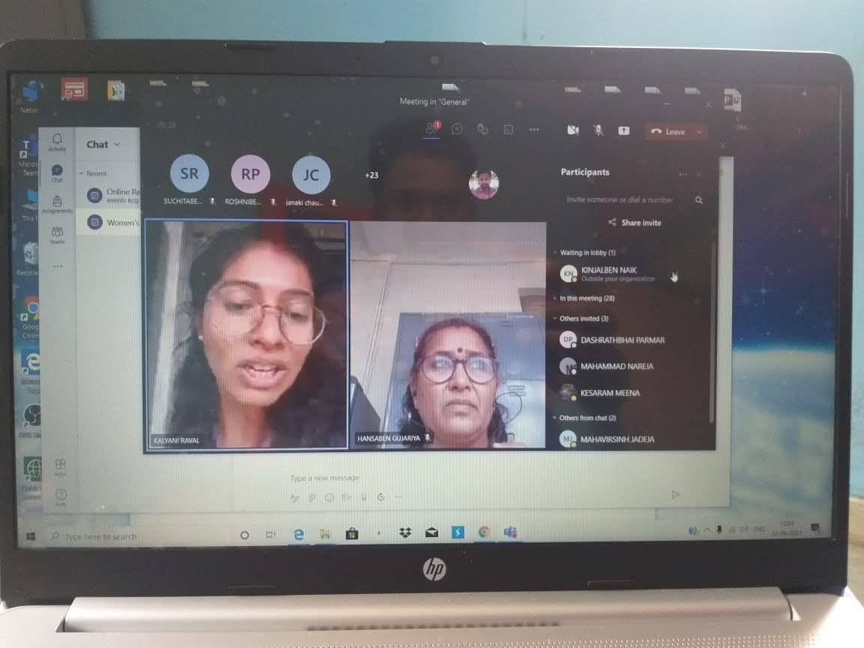
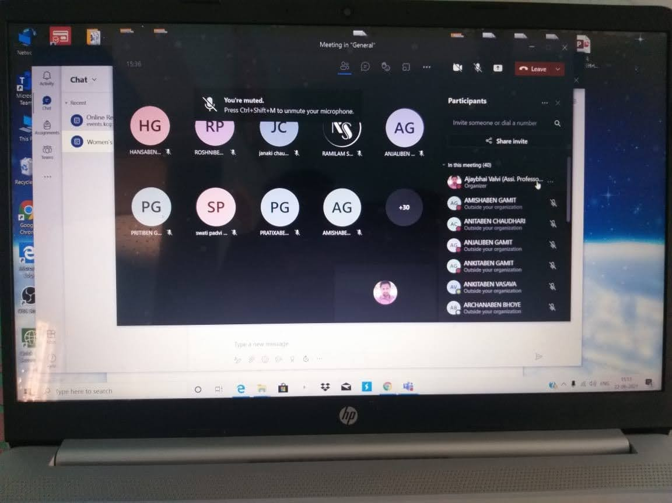

An Expert Talk on Understanding Health Issues & Menstruation in Women
Organised on 25/03/2021 at Dharmendrasinhji Arts College, Rajkot.

